025:250 COMPOSITION: ELECTRONIC MEDIA I

Fall 2013
Assignment 2
Presented in class Sept. 23-25

1. Go through your groups from Assignment 1 and do the following:
a. Use automated volume to balance the regions in each gesture. The metal sounds should be significantly lower
in volume.
b. Consider removing all vocal sounds, unless you want to make them the focus of your piece. In that case, use
many vocal sounds.
c. With any region that ends sharply and abruptly, consider a gentle fade out.
d. Arrange the regions so that one is on Track 1, another on Track 2, etc. Avoid using more than 1 region on a track
in each gesture. Also, avoid using empty tracks between non-empty tracks.

2. Discussion of cyclic permutations.

3. Choose any 5 gestures, ungroups them, and arrange them in a manner similar to the example below:
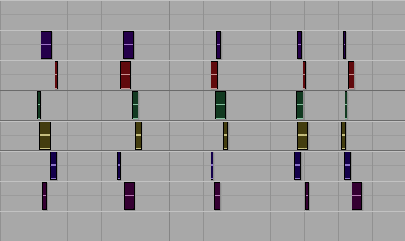
- Each grouping of regions will be called a gesture.
b. The 5 gestures above will be called Gesture Set 1.

4. Copy and paste Gesture Set 1 to the right, as shown below.
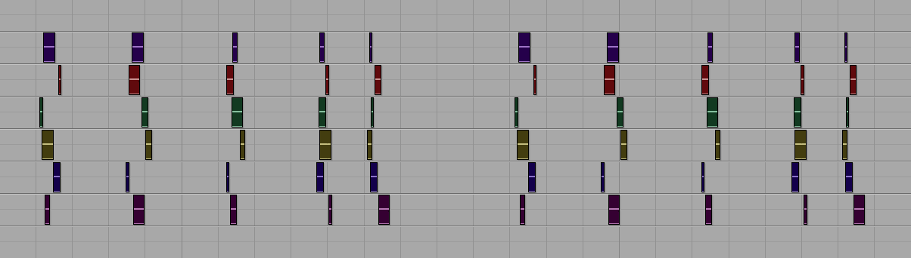
a. The gestures on the right will be called Gesture Set 2.

5. Transpose the regions of Gesture Set 2 as follows:
a. Tracks 1-2 by +2 semitones.
b. Tracks 3-4 by +4 semitones.
c. Tracks 5-6 by -1 semitone.
d. Alternatively, you could transpose by different intervals on any number of tracks.

6. Drag the individual regions in Gesture Set 2 to cyclically permute them as follows:
a. The regions in Track 1 rotate 1 space from right to left.
b. The regions in Track 2 rotate 2 spaces from right to left.
c. The regions in Track 3 rotate 3 spaces from right to left.
d. The regions in Track 4 rotate 4 spaces from right to left.
e. The regions in Track 5 stay in place.
f. The regions in Track 6 rotate 1 space from left to right.
g. When moving the regions, the precise placement of each one should be artistically made.
h. Steps a-g are shown below.
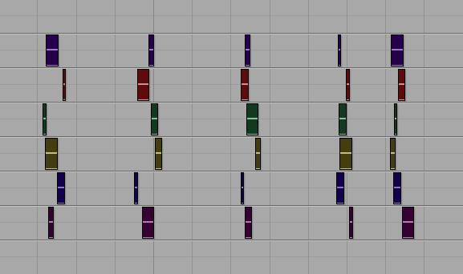 | 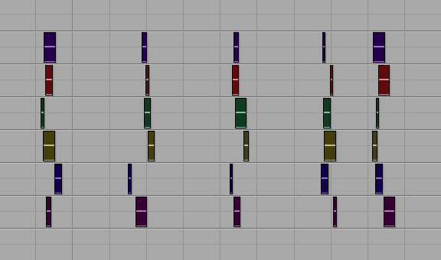 | 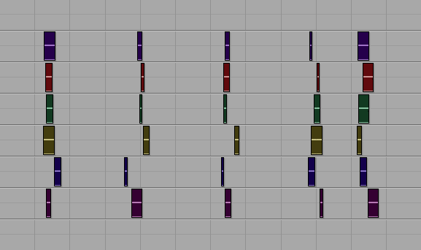 | 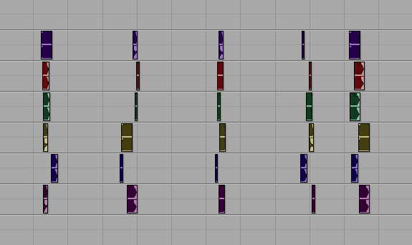 |  | 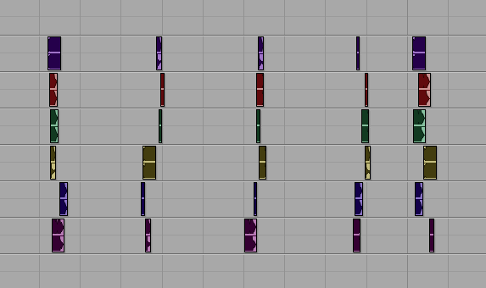
a | b | c | d | e | f

7. Create a new Gesture set and repeat steps 3-6. Do this until you have used every gesture in Assignment 1.

8. If any problems or confusion arise, set up a meeting with Dan and Will. You also have my permission to find an
artistic solution to any problem that arises.

